

*shell programming*

aSsignment -5

**SUBMITTED BY: SUBMITTED TO:**

**AYUSH KUMAR JHA Dr. Dhiviya Rose**

**SAP ID - 500086400**

**Enrollment no - R200220083**

**B.C.A -I.O.T.**

1. **Write an awk command to print the lines and line numberin the given input file .**

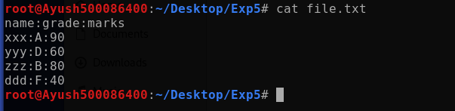

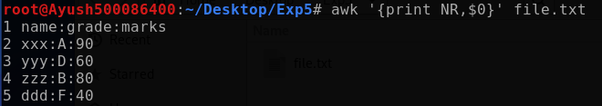

1. W**rite an awk command to print first field and second field only if third field value is >=50 in the given input file. (input field separator is “:” and output field separator is “,”)**

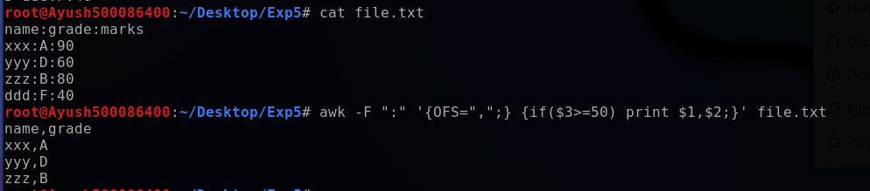

1. **Consider the marks.txt is a file that contains one record per line( comma separate fields) of the student data in the form of studentid, student name, Telugu marks, English marks, Maths Marks, Science marks, Social Marks. Write an awk script to generate result for every students in the form of studentid, studentname, Total Marks and result. Result is PASS if marks is >=30 in TELUGU and English, and if marks>=40 in other subjects. Result is fail otherwise.**

